# Conflict Scenario

## **Review**

### Interpersonal Conflict Management Styles

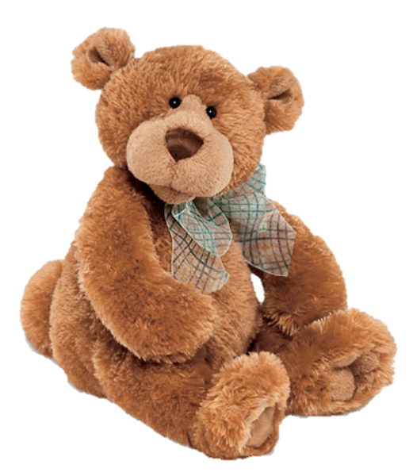

[CC 2.0 BY Matthew](https://www.flickr.com/photos/falcon1961/3304306800/)



[CC SA 3.0 Unported BY Jonathan Zander](https://en.wikipedia.org/wiki/File:Florida_Box_Turtle_Digon3.jpg)



[CC 3.0 BY Superawesomevectors](https://superawesomevectors.deviantart.com/art/Shark-Cartoon-Free-Vector-Illustration-643399222)



[CC0](https://pixabay.com/en/urban-lost-hiding-afraid-1002149/)

Low to High Concern for Other

Concern for Self



CC SA 2.0 Generic BY [Carine06 from UK](https://commons.wikimedia.org/wiki/File:Flickr_-_Carine06_-_%22I_give_up.%22.jpg)



CC 2.0 BY [Zabara Alexander](https://www.flickr.com/photos/zabara_tango/6955720271)



[CC0](https://commons.wikimedia.org/wiki/File:US_Army_53525_Soldiers_compete_in_Tae_Kwon_Do_tournament_for_Warrior_Country_level.jpg)

### **Interpersonal Conflict Resolution**

The following diagram shows a process that can be followed when trying to resolve interpersonal conflict.

### Listening

A considerable proportion of our communication involves listening, yet little attention is devoted to improving listening. HURIER is an acronym for tips that can be used to improve listening.

### “I” Phrases for Conflict Resolution

The “I” phrase is used during conflict resolutions to avoid attacking others. Open the conversation with a statement in first person, passive voice: “I feel … when … because … I would like …”

Adapted from (Dwyer 2012, p. 40)

## **Student Name and ID:** Corey Larkin 12199713 - Jane

## **Student Name and ID:** Elliot Chapman 12184779 - Joe

## **Scenario**

Find a partner. Read the scenario below. Choose one partner to be Joe Bloggs, and the other to be Jane Doe. Together, answer the following to help prepare you for the role play.

## **Scenario: Joe did not complete a task by the deadline**

Joe and Jane are working on a report that is due today. Joe was assigned the task of writing the executive summary. Unfortunately, Joe has not completed the task.

What is the most appropriate conflict management strategy for Jane to use in this situation? (Choose one)

Compete/Force

Compromise

Avoid/Withdraw

Collaborate/Confront

Accommodate/Smooth

Why did you choose the above conflict management strategy?

Looking through the list of other possible strategies we found that the best way would be collaborate/confront with Joe, mainly because it’s a less direct aggressive approach to say, why didn’t do you the work. Collaborating to achieve the outcome would be the best possible outcome for both parties as it’s a win/win situation.

Compete/Force can drive a wedge between Jane and Joe with Jane being too aggressive, thus preventing Joe from wanting to do anything or feel intimidated.

Compromise would indicate that even though Joe has not completed his part Jane is willing to complete some of if not all of the work for Joe – thus showing that Joe gets away from the situation without repercussions.

Avoid/Withdraw has no benefit as it doesn’t help Jane and Joe isn’t held accountable for not completing his part of the report.

Accommodate/Smooth could potentially be an alternate solution as you can come to an agreement between both parties or attempt to pick up the slack of the other person.

### **Listen and Understand**

How could Jane start the conversation?

Hi Joe, it’s to come to my attention that you have not completed the executive summary. Is there any reason for this, as you should know its due today?

Describe the purpose of the discussion. Describe the conflict. What questions could Jane ask to determine Joe’s perspective of the situation?

Purpose – to find the cause of Joe not completing his executive summary to come to a mutually beneficial solution.

Describe the conflict - Joe was supposed to complete his executive summary. Jane confronts Joe as to why he hasn’t done his executive.

Questions –

Why haven’t you completed this?

Were there extenuating circumstances that prevented you from completing this?

Did you require assistance? Why didn’t you come to me?

Write sentences that features the “I” phrase, such as in the example below:

“I feel *[your feeling]* when *[their behaviour]* because *[effects on you]*. I would like *[alternative behaviour]*”.

Jane –

I am upset that you haven’t completed the executive summary as it will affect both of us when we can not hand in a completed report. I would appreciate it if you seek me out in the future to avoid this sort of situation arising again.

Joe –

I understand that you are upset with me as I didn’t complete the summary that you requested of me. I can definitely see that it will affect both of us and I will come to you sooner if something like this was to arise again.

Invent a reason why Joe did not complete the executive summary by the deadline.

I have been suffering from a lot of stress recently due to an unexpected death in the family. It’s been affecting my work and it has been difficult to remain focused on anything.

How could Jane paraphrase Joe’s reason for missing the deadline to ensure that she understands Joe’s perspective?

From what I understand Joe, it has been difficult for you to remain focused on your work due to an unexpected family death. Is this correct?

### **Empathise**

Now that Jane understands Joe’s perspective, how could Jane empathise with Joe? Write a response that shows that Jane identifies with Joe’s emotions.

Firstly, I am sorry for your loss, I had no idea something like that was weighing on you. I can understand how you must feel and what you are going through. If there is anything I could do for you just ask.

### **Apologise**

Include an apology if it is appropriate.

Reflecting on empathise above.

Sorry, I didn’t realise what you were going through.

### **Offer Solution**

What question could Jane ask to help build Joe’s involvement with potential solutions?

If we could get a small extension due to the circumstances, do you think we will be able to work together to complete this?

Are you willing to sit down with me and figure out how we can complete the executive summary by today?

Come up with a way for Jane and Joe to settle on a solution.

Jane and Joe need to meet halfway and talk seriously about the potential repercussions involved and what they can do to come to a suitable solution which appease both parties.

### **Resolution**

How could Jane resolve the conflict? Jane needs to ensure that Joe agrees. Write a response that outlines appreciation for the solution.

From what I understand so far Joe, you’ve not been able to complete the summary due unforeseen circumstances. What I would suggest is we put our heads together for today to get a summary completed as best we can, to indicate we have attempted to put something together. As well as doing this, I would also suggest speaking to our Lecturer about the situation to shed some light on why this wasn’t perhaps as good as it could have been. Do you agree with this as a solution?

### **Reconciliation**

How could Joe reconcile the relationship and let Jane know that she is important to him?

Thank you for your understanding and I appreciate you. Can I take you to lunch sometimes as a sign of gratitude?

How can Jane let Joe know she is listening while Joe is talking?

Keep quiet, avoid interrupting and actively listen while Joe is talking by nodding in agreement (non-verbal cues) to show understanding, and paraphrasing what Joe has said and ask probing question

What could Jane do if Joe started to withdraw from the conflict at any stage?

Jane could give Joe some space in the interim (if possible). Maybe give him some time to cool off and collect his thoughts. Show understanding and reinforce the argument as to the importance of completing the summary.